Advisory: #LASD - L.A. SHERIFF’S DEPARTMENT VOLUNTEERS PROVIDE OVER $11.1 M IN SERVICES DURING 2014!!!  Dear Nixle User,  In 2014 the Los Angeles County Sheriff’s Department Volunteers save L.A. County $11,162,079.23! They volunteered a total of 450,993 hours performing various law enforcement support functions. Their duties include Volunteers on Patrol, Mounted Posse, CERT (Community Emergency Response Team) and administrative support functions.  These 3,532 volunteers come from all walks of life and all socio-economic levels. Many are retired while some are students and currently enrolled in local universities and community colleges. They maintain their outside full or part-time jobs while at the same time donating a minimum of 16 hours every month to the Sheriff’s Department.. Many Volunteers put in much more than the minimum requirement  They have all successfully completed a Volunteer Orientation and or Volunteer on Patrol Academy and various other trainings, totaling hundreds of volunteer hours.  For additional information regarding the excellent work performed by these outstanding volunteers or to find out how to volunteer for the Sheriff’s Department contact the Community Partnerships Bureau’s Volunteer Program at 562-347-1080 or email cleppoffice@lasd.org.  Sheriff's Information Bureau - Newsroom  Los Angeles County Sheriff's Department  323-267-4800  Email: SHBNewsroom@lasd.org  Website: http://www.lasd.org  Follow us at: Text and Emails, LASD HQ: http://www.Nixle.com  http://nixle.com/lasd----hq-newsroom-shb-los-angeles-county-sheriff/  Twitter: @LASDHQ http://twitter.com/LASDHQ  Twitter: @LASDtalk https://twitter.com/LASDTalk  Twitter: @LASDvideos https://twitter.com/LASDvideos  Twitter: @LASDespanol https://twitter.com/LASDespanol  Facebook LASD HQ: http://www.facebook.com/LosAngelesCountySheriffsDepartment  Instagram LASD Photos: http://instagram.com/LASDHQ Pinterest  LASD Photos : http://pinterest.com/lacountysheriff/  YouTube LASD Videos: http://www.youtube.com/user/LACountySheriff/videos?view=0  Alert LA County: Telephone emergency mass notification system http://www.lacounty.gov/wps/portal/alertla  SNAP LA County: Specific Needs Disaster Voluntary Registry http://snap.lacounty.gov/  Text & Email, Register for LASD Nixle messages: To receive more detailed, up-to-date information via E-MAIL and/or TEXT directly from the Los Angeles County Sheriff’s Department (LASD), sign up for "Nixle" alerts at http://www.Nixle.com and register for "LASD – Headquarters Newsroom (SHB), Los Angeles County Sheriff" AND your local LASD station area. Or, to receive URGENT TEXT ALERTS ONLY, text your zip code to 888777. Standard text messaging rates may apply depending on your calling plan.  "If You See Something, Say Something"  LA Crime Stoppers: Partner to prevent or report crime by contacting your local Sheriff’s station. Or if you wish to remain Anonymous, call “LA Crime Stoppers” by dialing 800-222-TIPS (8477), texting the letters TIPLA plus your tip to CRIMES (274637), or using the website http://lacrimestoppers.org  Jim McDonnell, Sheriff  Los Angeles County Sheriff's Department  For full details, view this message on the web. | 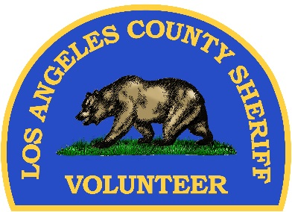

Sent by LASD - Los Angeles County Sheriffs Dept Information Bureau (SIB)
4700 West Ramona Boulevard, Monterey Park, CA 91754
To manage your email settings, click here.

