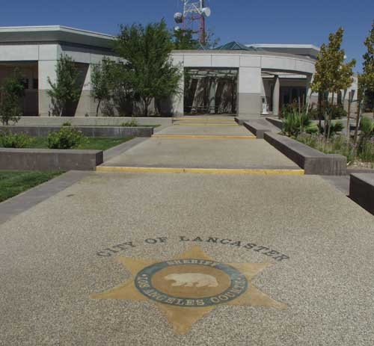
ABOUT US

Located in the northernmost portion of Los Angeles County, Lancaster Station has 189 sworn personnel and 74 civilian personnel assigned. Lancaster Station is located in the beautiful Antelope Valley, approximately 55 miles northeast of the City of Los Angeles. Station personnel cover an area of more than 600 square miles, including the contract City of Lancaster, and communities of Lake Los Angeles, Quartz Hill, and Antelope Acres. Quality law enforcement services are provided for over 190,000 residents.

The Lancaster Station has the following community services and program available. Call us for more information.

Reserve Program-Sergeant Theresa Dawson / Les White | (661) 940-3882
Search and Rescue- Sergeant Theresa Dawson/ Les White | (661) 940-3882
Crime Prevention/ Community Relations –Sergeant Theresa Dawson  Deputy Joshua Stamsek  Deputy Kit Gruppie | (661) 940-3882  (661) 940-3832  (661) 524-2154
Neighborhood Watch- Sergeant Theresa Dawson  Deputy Joshua Stamsek  Deputy Kit Gruppie | (661) 940-3882  (661) 940-3832  (661) 524-2154
Ride-A-Longs – Deputy Kit Gruppie | (661) 524-2154
Station Tours – Deputy Joshua Stamsek  Deputy Kit Gruppie | (661) 940-3832  (661) 524-2154
Volunteers Program – Deputy Joshua Stamsek | (661) 940-3832
Explorer Program – Deputy Lance Jordan | (661) 948-3831
VIDA Program | (661) 949-6585
Crime Tip Hotline http://www.lacrimestoppers.com/ | 1-800-222-TIPS (8477)
Traffic Reports | (661) 940-3812

