The ABCs of Back to School Preparedness
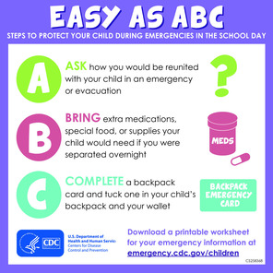
With school bells ringing across the Nation, it is time for parents and guardians to get familiar with the emergency plan at your child’s school or daycare.

Much like individuals and families, schools and daycare providers should all have site-specific emergency plans. If you are a parent or guardian, it is important to make sure your child’s school or daycare has a plan to ensure his or her safety during an emergency.

The Centers for Disease Control and Prevention (CDC) outline steps as easy as ABC to keep your child safe at school or daycare:
- Ask how you will reunite with your child in an emergency or evacuation.
- Bring extra medication, special foods, or supplies that your child might need.
- Complete a backpack contact information card.

If your child has an access or functional need, be sure to meet with a school official to discuss plans for how the school will provide for his or her safety. For more information about emergency preparedness for parents, educators, and kids, visit www.ready.gov/kids.

Parents, guardians, and teachers can also use the Children and Youth Preparedness Social Media Toolkit to share safety messages on their social media networks.

